Hands-On Session: Windows Server Installation
Date: 6 September

Overview
This document summarizes the hands-on session conducted on 6 September, focusing on the installation and setup of Windows Server 2022 and client machines using VMware. The session included the creation of a domain controller (DOMCON), a client PC (CLIENTPC1), and a cloned client PC (CLIENTPC2).

1. Installation of Windows Server 2022 (DOMCON)
Steps to install Windows Server 2022 on DOMCON:
• Launch VMware and create a new virtual machine.
• Select 'Typical' setup and choose the Windows Server 2022 ISO file.
• Name the VM as DOMCON and set the location for VM files.
• Choose operating system: Microsoft Windows > Windows Server 2022.
• Allocate resources: 2 CPU cores, 4–8 GB RAM, 60+ GB disk space.
• Complete the wizard and start the VM.
• Follow the Windows installation wizard and select 'Windows Server 2022 Standard (Desktop Experience)'.
• Create partitions and install the OS.
• Set a strong Administrator password after installation.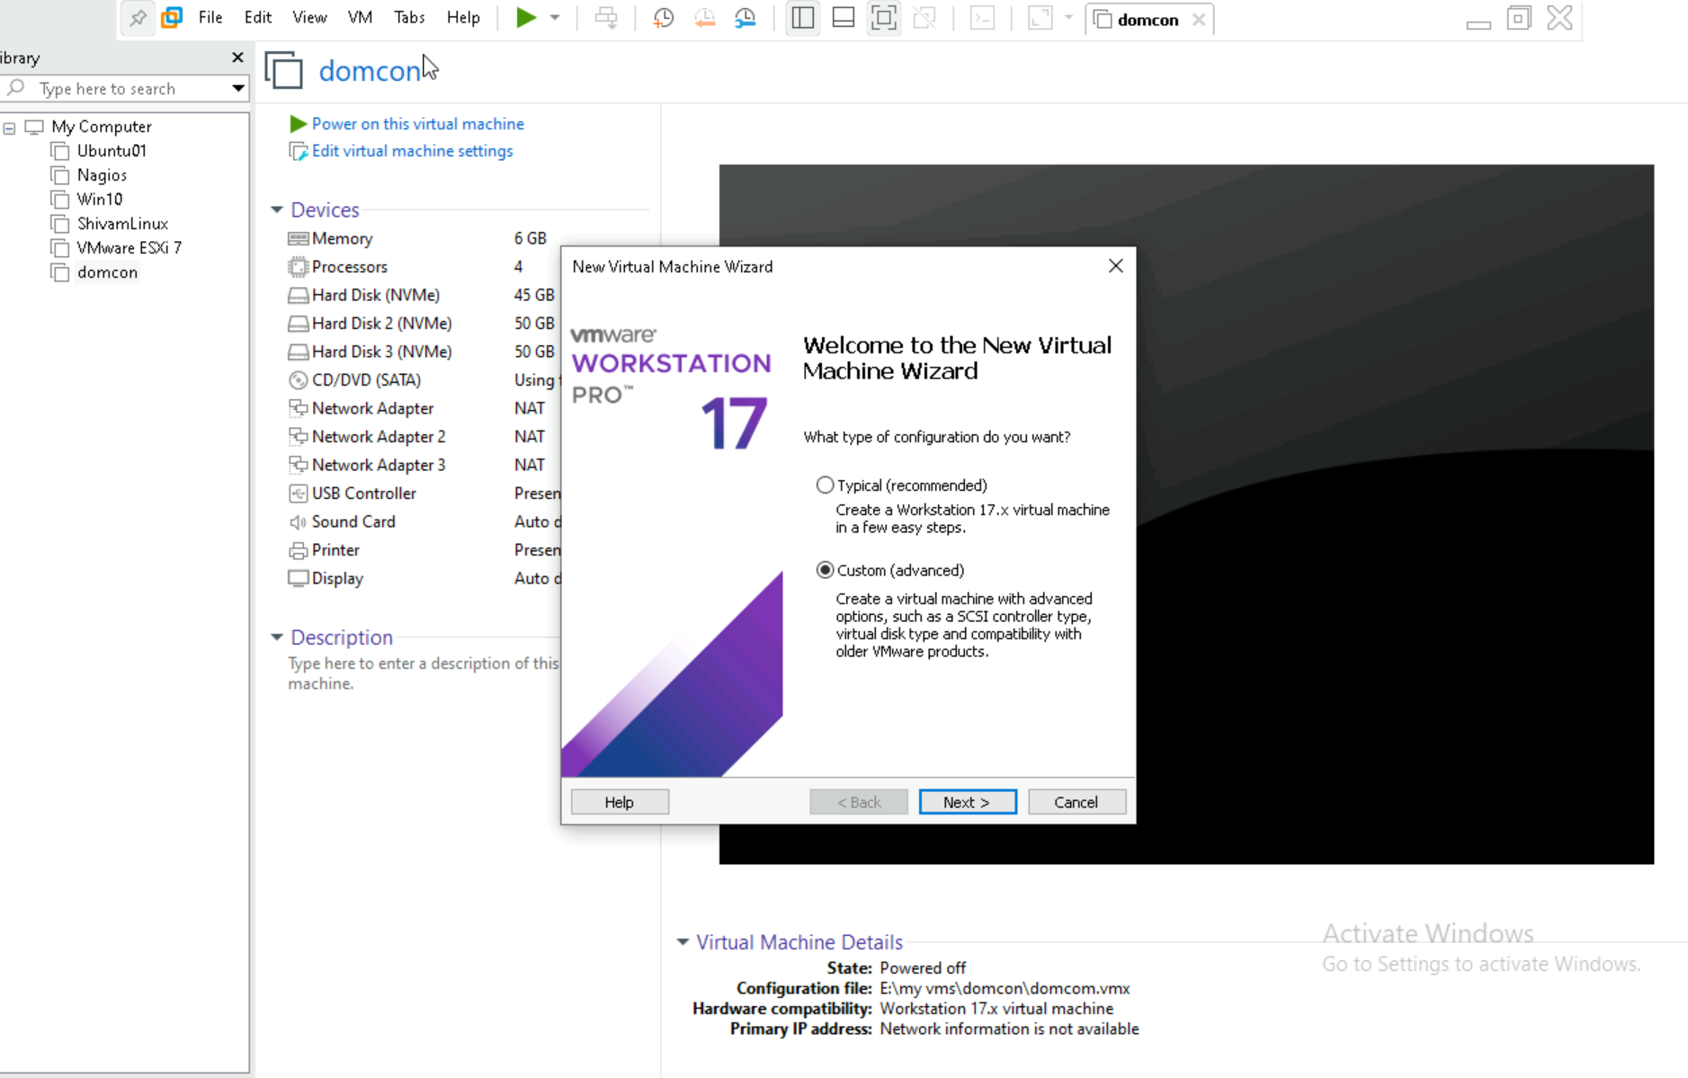
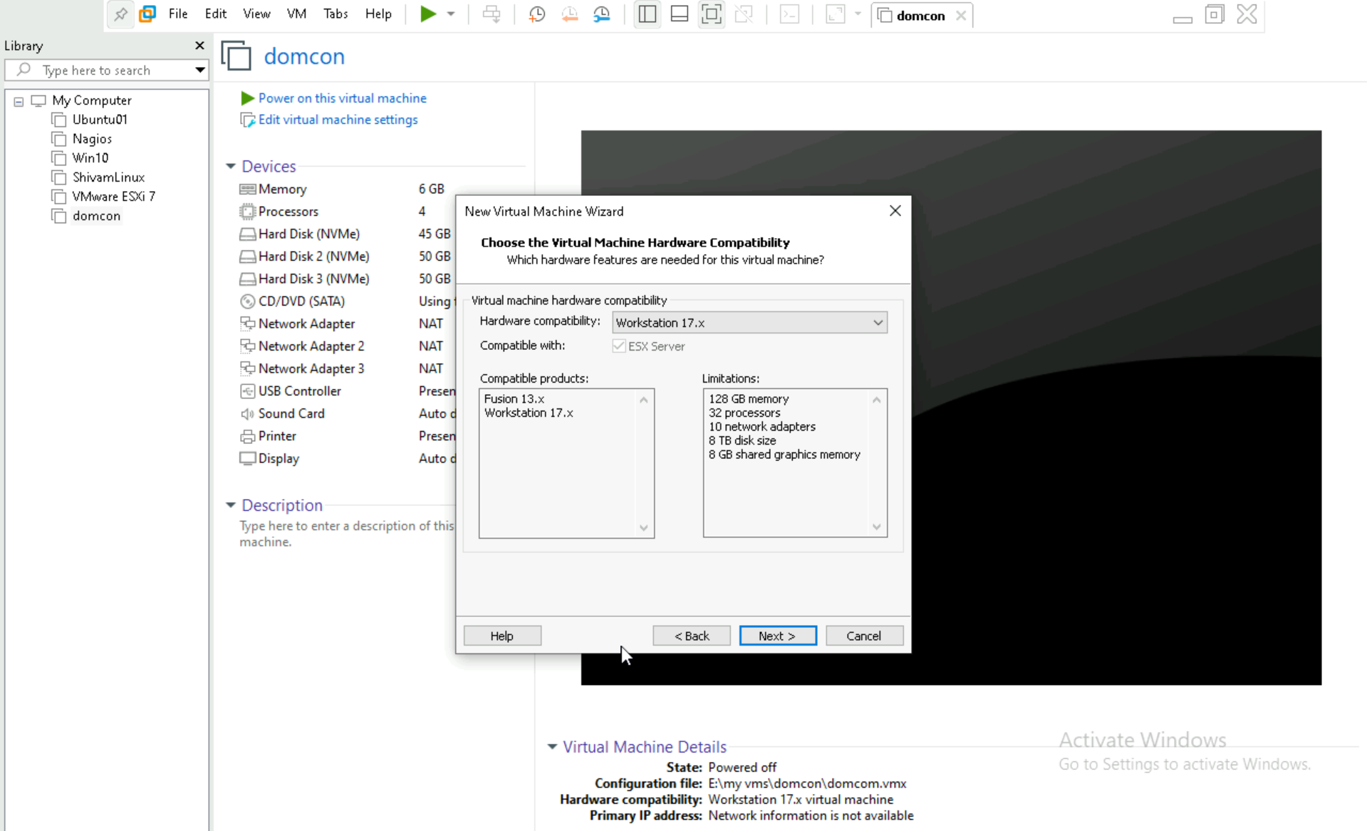
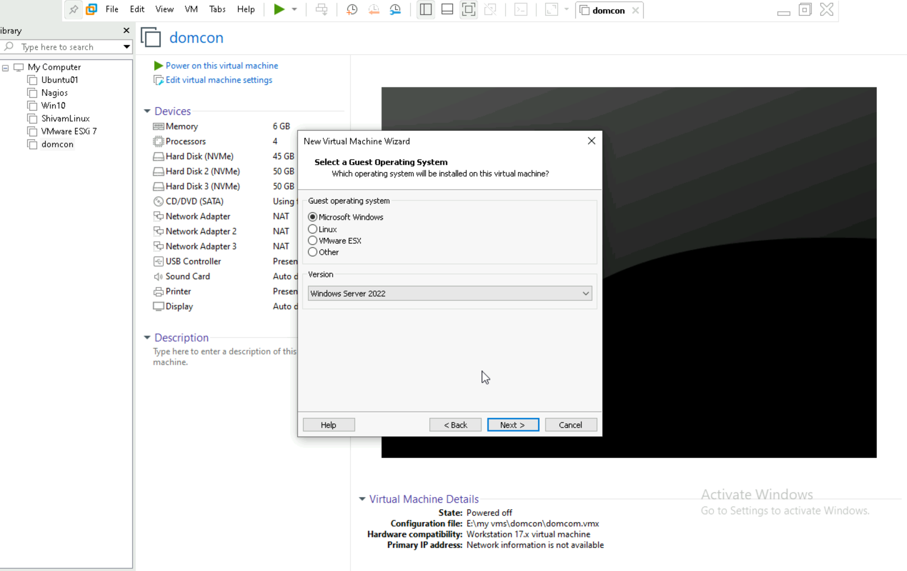

2. Installation of Windows 11 Client (CLIENTPC1)
Steps to install Windows 11 on CLIENTPC1:
• Create a new virtual machine in VMware.
• Select the Windows 11 ISO file.
• Name the VM as CLIENTPC1.
• Choose operating system: Microsoft Windows > Windows 10/11.
• Allocate resources: 2 CPU cores, 4 GB RAM, 40+ GB disk space.
• Complete the wizard and start the VM.
• Follow the Windows installation wizard and set up a local account.
• Rename the PC to CLIENTPC1.
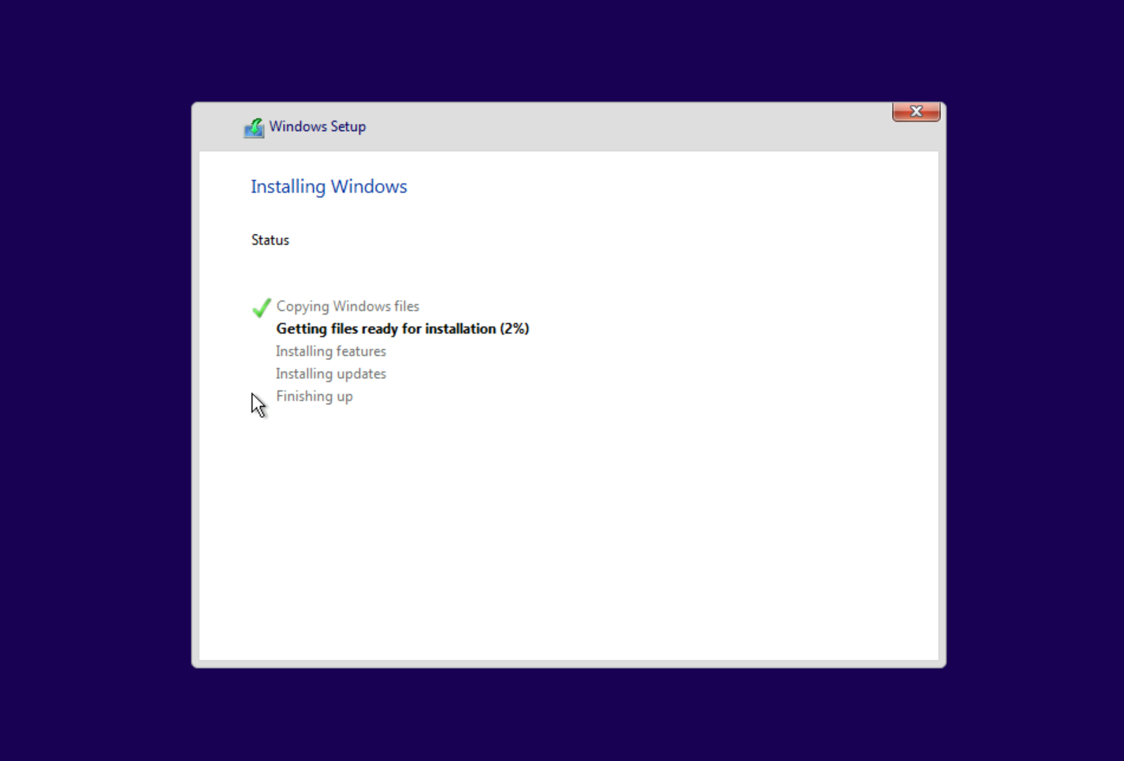

3. Cloning CLIENTPC1 to Create CLIENTPC2
Steps to clone CLIENTPC1 and configure CLIENTPC2:
• In VMware, right-click CLIENTPC1 and select 'Manage' > 'Clone'.
• Choose 'Create a full clone'.
• Name the new VM as CLIENTPC2.
• Complete the cloning process.
• Start CLIENTPC2 and go through initial setup.
• Rename the PC to CLIENTPC2.

